ĐÔNG XUYÊN Primary School  Class: 3……  Name: ……………………………. | BÀI KIỂM TRA ĐỊNH KỲ CUỐI HỌC KỲ I  NĂM HỌC 2018-2019 - MÔN: TIẾNG ANH  Thời gian làm bài: 40 phút

Skill | Listening | Reading | Writing | Speaking | Total
Mark

PART 1: LISTENING (20 minutes)
Question 1: Listen and number (1 point)
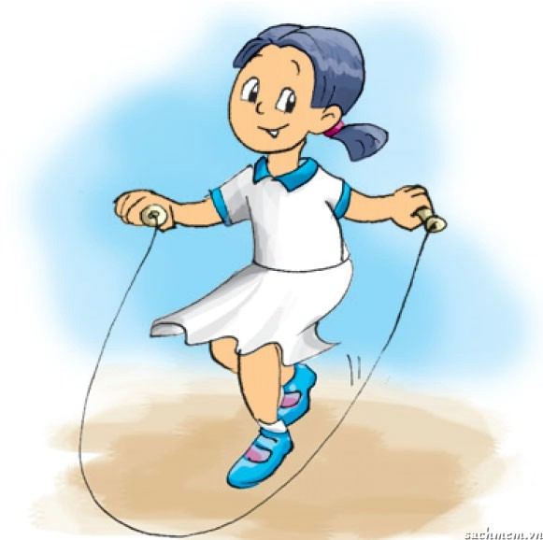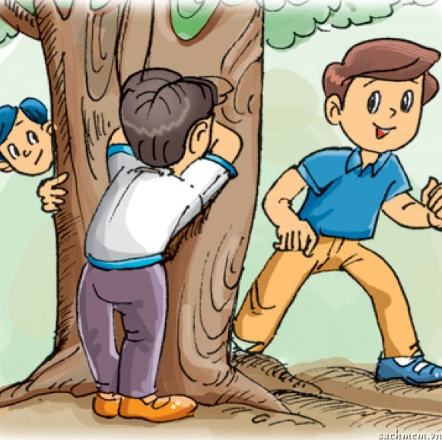

Question 2: Listen and match (1 point)

big
small
large
old

  1. |   2. |   3. |   4.

Question 3: Listen and complete (1point)
- Laura: How old is Peter?
  - Bob: He’s _________ years old.
- How do you spell your name?
- ___ ___ ___ ____ ____
- 3. Mary: Is your classroom __________?
  - Jack: Yes, it is.
- Linda: What’s that?
  - Tony: It’s a _______________.

Question 4: Listen and tick (√) the box. There is one example. (1 point)

- 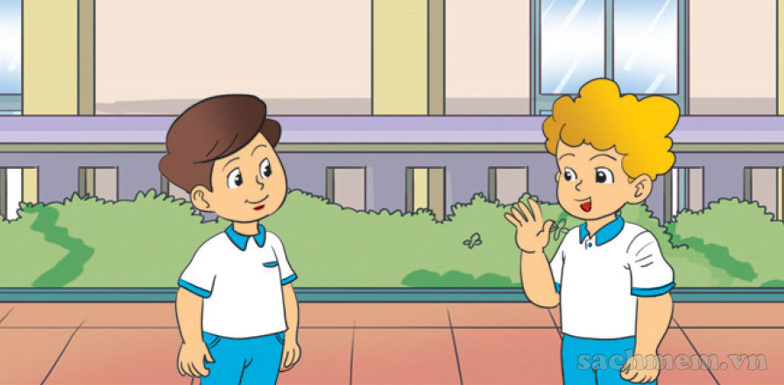  A. | 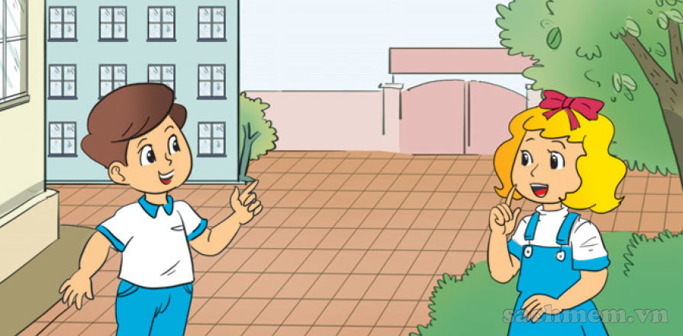  B.
- 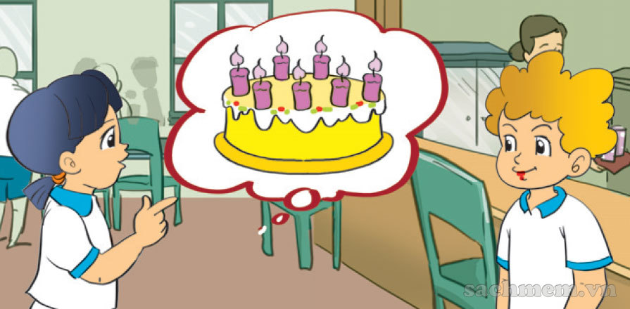  A. | 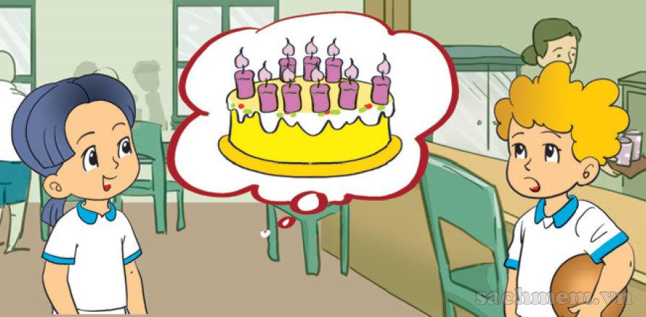  B.
- 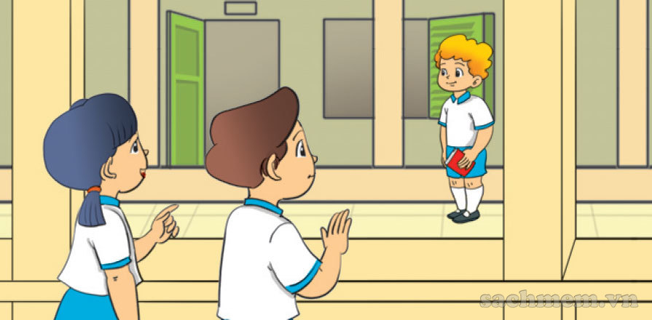  A. | 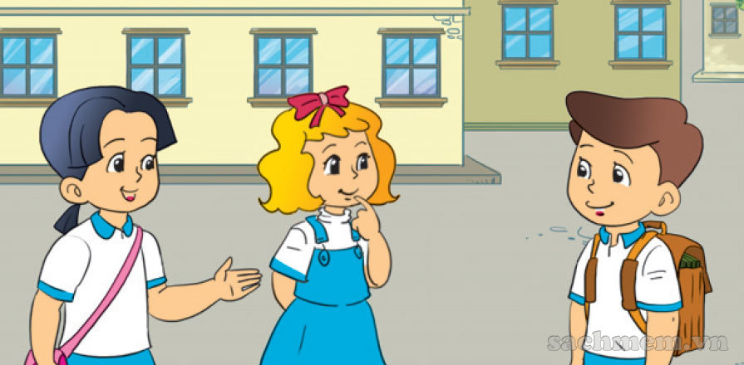  B.
-   A. | 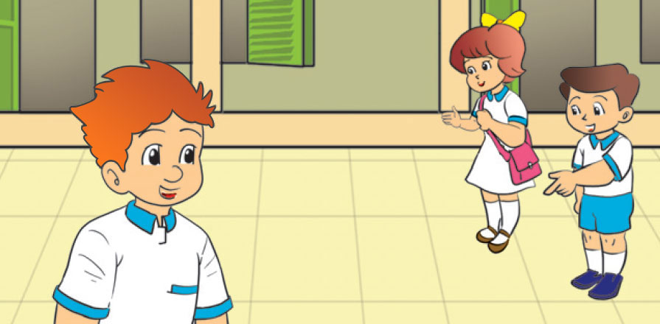  B.
- 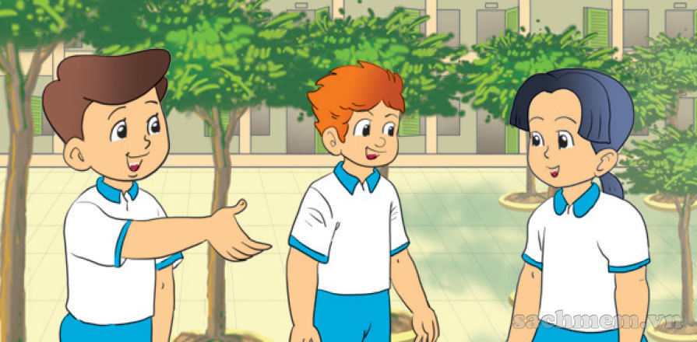  A. | 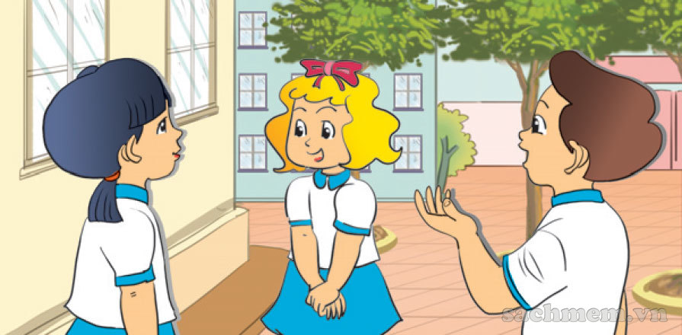  B.

PART II: READING
Question 5: Look and read. Put a tick (√ ) or cross ( X) in the box. There is one example. (1 point)

0. Close your book, please. |  | 
0. I like skipping. |  | 
1. I like playing badminton. |  | 
2. This is my pen. |  | 
3. These are my rubbers. |  | 
4. Those are my pencils. |  | 

Question 6: Read and tick (√) True or False. There is one example. (1 point)

Hi. My name is Nam. This is my classroom. It is small but nice. This is my desk and these are my school things. This is my school bag. It is big. These are my books and notebooks. They are new. These are my pencil cases and pens. They are new too. Look! Those are my new friends. True (Đ) False (S)

0. My name is Nam. | √
1. My classroom is small but nice.
2. My school bag is small.
3. My books are old.
4. My pens and pencil cases are new.
5. These are my new friends.

Part 3: Writing
Question 7: Look at the pictures and letters. Write the words. (1 point)

1.epn ➔ _ _ _ | 2. r b e u b r ➔ _ _ _ _ _ _
  3.chsool ➔ _ _ _ _ _ _ | 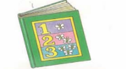4.ookb ➔ _ _ _ _

Question 8: Choose a word from the box and write it next to numbers (1 point)

Nam | old | eight | are

Hello! My name is (1)…………….... ……..I’m (2) ………….... …….. years old. These (3) ………….... ……..my friends Peter and Linda. Peter is seven years (4) ………….... …….. and Linda is nine.

PART IV: SPEAKING PART
Question 9: Interview (2 points)
1. What is your name?
2. How do you spell your name?
3. What do you do at break time?
4. Do you like skating?

--THE END--

